**TEAM-8**

**ART GALLERY MANAGEMENT SYSTEM**

PES2UG19CS104- DEEKSHITHA R

PES2UG19CS105- DEEPA SHREE C V

**Problem Statement**:

To create an efficient database management system for an Art Gallery.

**Introduction:**

This project primarily deals with managing details of paintings, employees, customers and other stakeholders. We can maintain a record of the paintings present in the gallery, details of customers who buy these paintings. We can also enter new paintings available for sale. We can also record the details of the employees who work there.

**A few assumptions of our dbms model:**

* The mini world is a single gallery
* An exhibition can hold only one auction but the same painting can be put up on several auctions if it’s unsold. And in each auction only one painting is sold
* NULL value in the price_fetched column of auction refers to unsold.

**Justification for the usage of PostgreSQL as the DBMS software:**

* Open Source DBMS
* Diverse indexing techniques
* Flexible Full-text search
* Diverse kinds of replication
* Diversified extension functions
* Supports ACID(Atomicity, Consistency, Isolation, Durability) and Transaction

**Mapping from ER model to Relational model:**

**Step 1:** Convert all Strong Entity Sets in to Relations(Tables)

Strong Entity Sets - Artist, Customer, Department, Employee, Exhibition, Painting

Write down the tables for them mentioning all their attributes excluding the multivalued attributes. Only the constituent attributes of the composite attributes are written in the tables.

**Step2:** Mapping of Weak Entity Types

Weak Entity Types – Auction, Instalments

While creating tables for the Weak entity types, we will add the primary key of the Strong entity to which it is associated as the foreign key.

**Step3:** Mapping 1:1 Relationship Types

HAS, HEADS

We are using the Foreign Key Approach Method for this; the primary key of one entity is added as the foreign key to the other entity with total participation.

**Step4:** Mapping 1:N / N:1 Relationship Types

PAYS, BUYS, PAINTS, MANAGES, BELONGS_TO

Add primary key of entity set with cardinality “1” as foreign key to the entity set with cardinality “N”.

**Step5:** Mapping M:N Relationship Types

EXHIBITED_IN

Create a new relation/table including primary keys of both the entity sets. Add the descriptive attribute also, if any.

**Step6:** Mapping Multivalued Attributes

For each Multivalued attribute, create a new separate relation. Add primary key of the entity set in new relation as a foreign key. The foreign key attribute and multivalued attribute both together are called the “composite key” for this relation.

**Relational Model:**

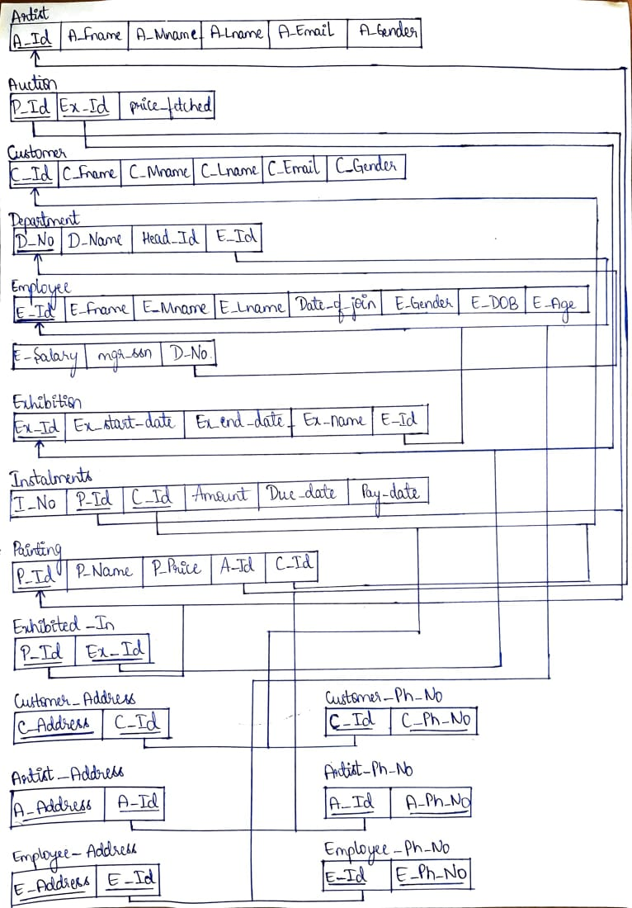

**Creation and Insertion of relations in PostgreSQL:**

**List of relations:**

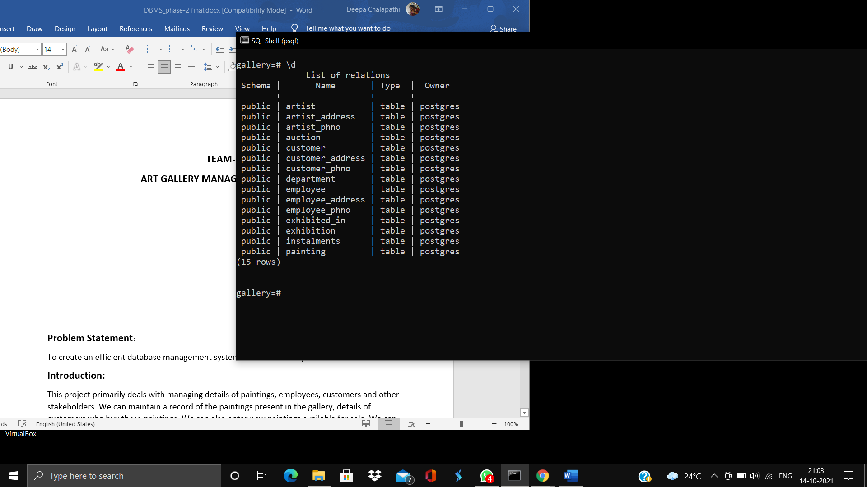

**Create statements:**

**Artist:**

create table artist(

a_id varchar(30) not null unique primary key,

a_fname varchar(30) not null default ‘None’,

a_mname varchar(30),

a_lname varchar(30) not null default ‘None’,

a_email varchar(30) not null unique,

a_gender varchar(6) default ‘None’);

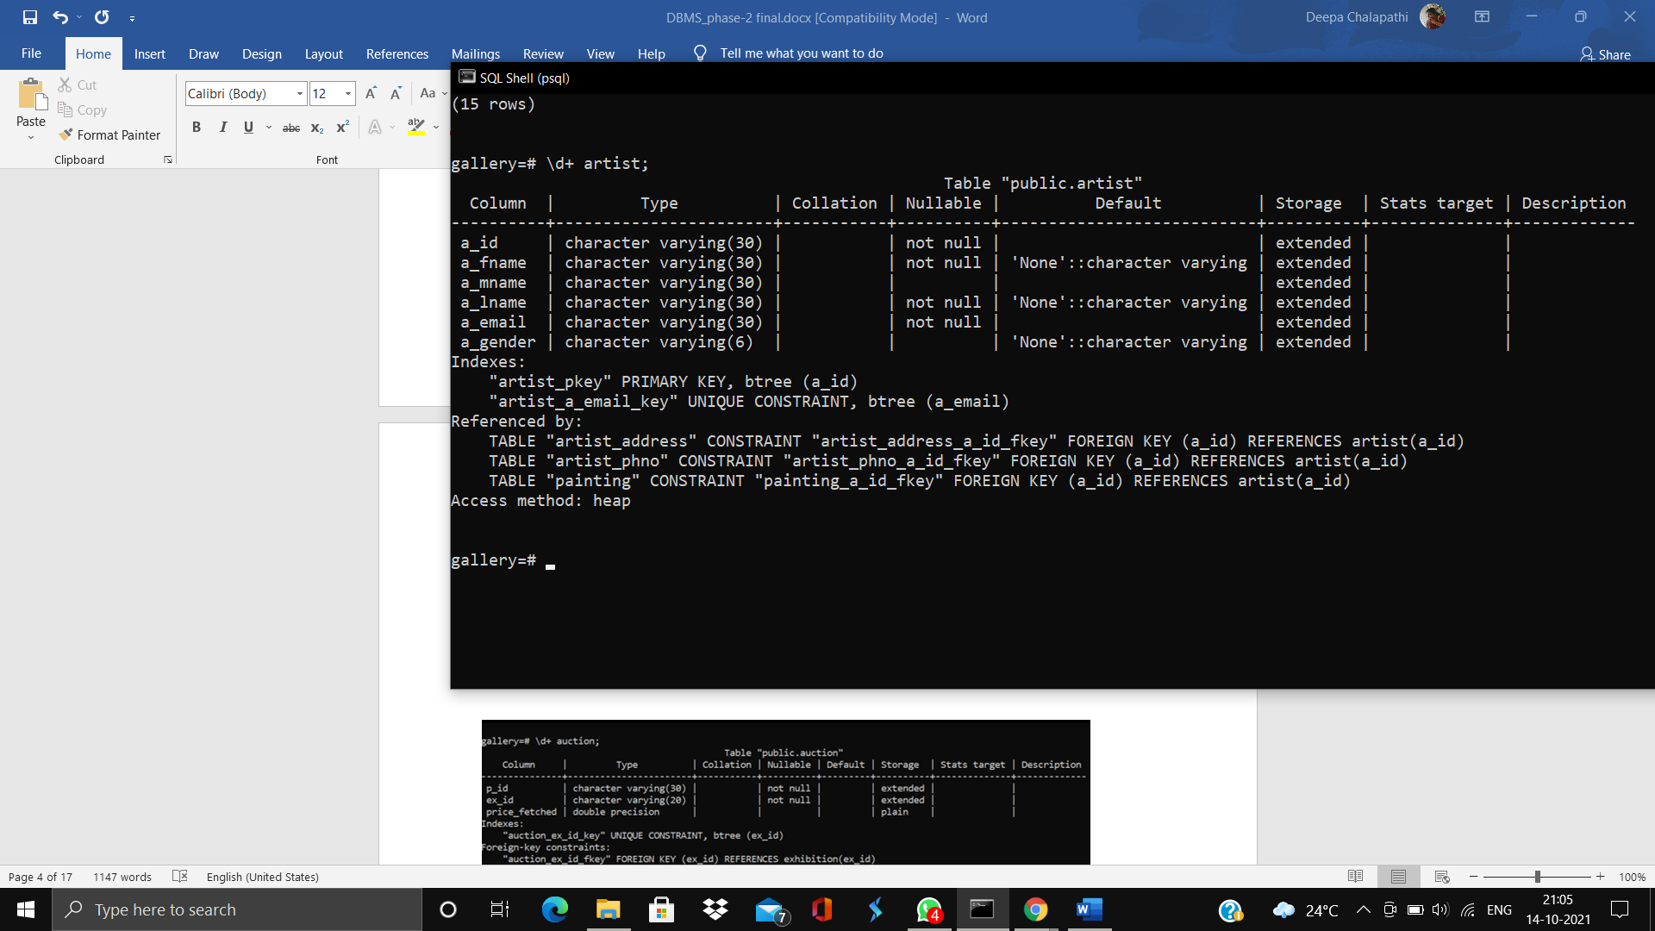

**Artist_address:**

create table artist_address(

a_id varchar(30) not null unique,

a_address varchar(100),

foreign key (a_id) references artist(a_id));

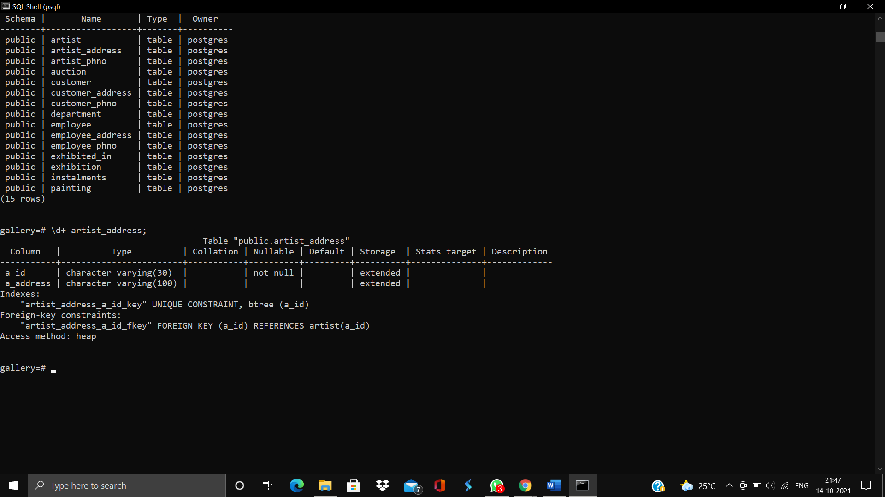

**Artist_phno:**

create table artist_phno(

a_id varchar(30) not null unique,

a_ph_no numeric,

foreign key (a_id) references artist(a_id));

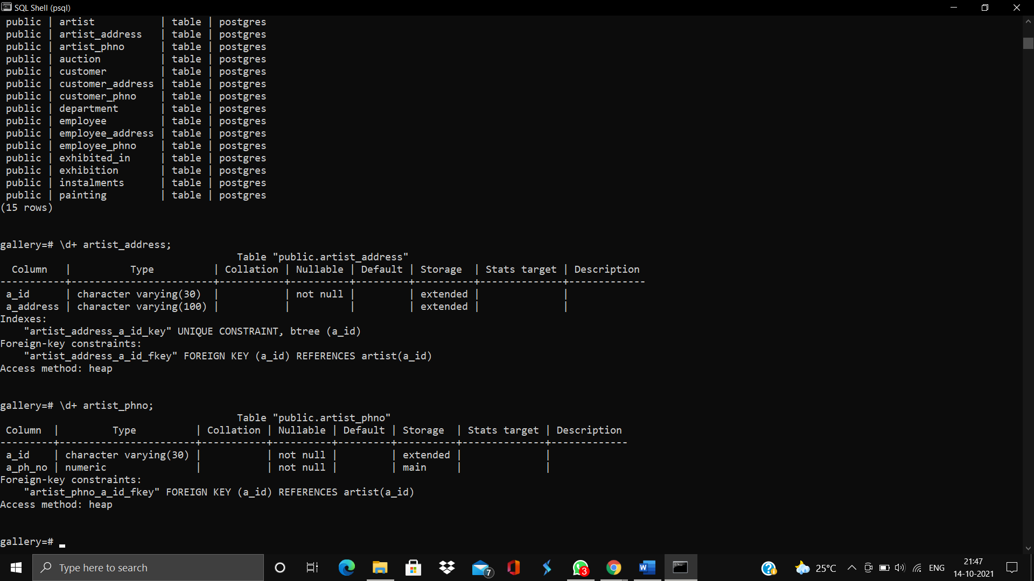

**Auction:**

create table Auction(

p_id varchar(30) not null;

ex_id varchar(20) not null unique,

price_fetched float);

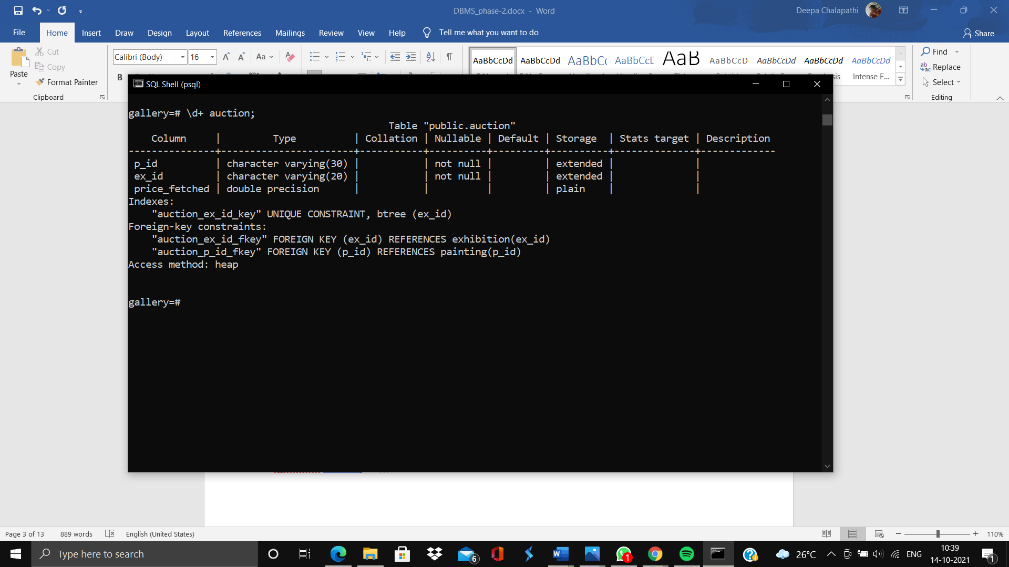

**Customer:**

create table customer(

c_id varchar(30) not null unique primary key,

c_fname varchar(30) not null default ‘None’,

c_mname varchar(30),

c_lname varchar(30) not null default ‘None’,

c_email varchar(30) not null unique,

c_gender varchar(6) default ‘None’);

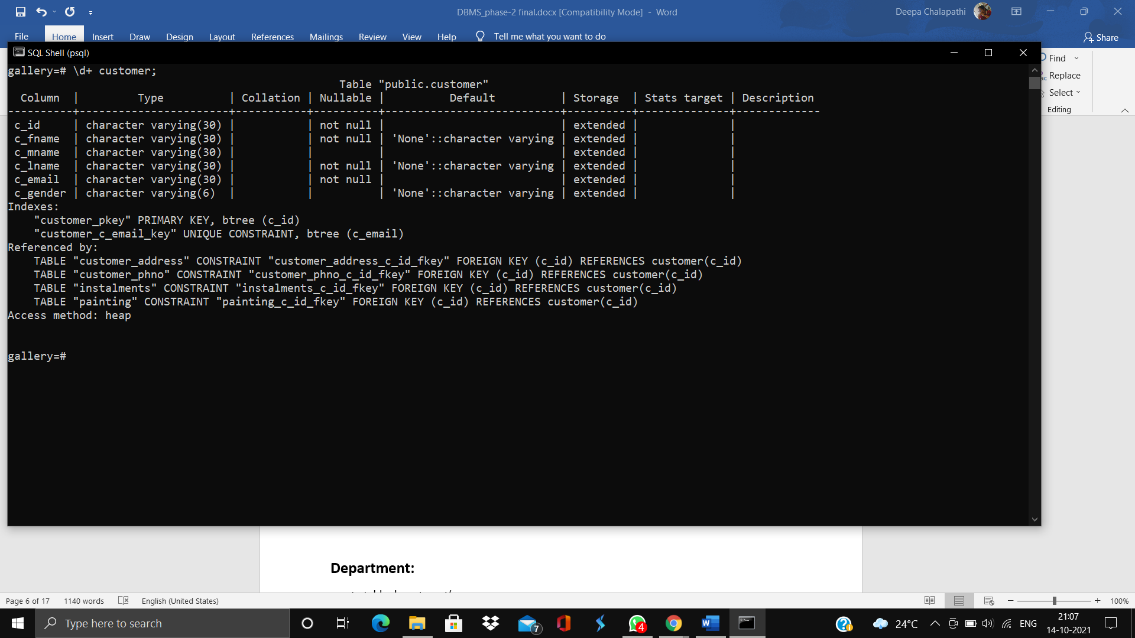

**Customer_address and Customer_phno:**

create table customer_address(

c_id varchar(30) not null unique,

c_address varchar(100),

foreign key (c_id) references customer(c_id));

create table customer_phno(

c_id varchar(30) not null unique,

c_ph_no numeric,

foreign key (c_id) references customer(c_id));

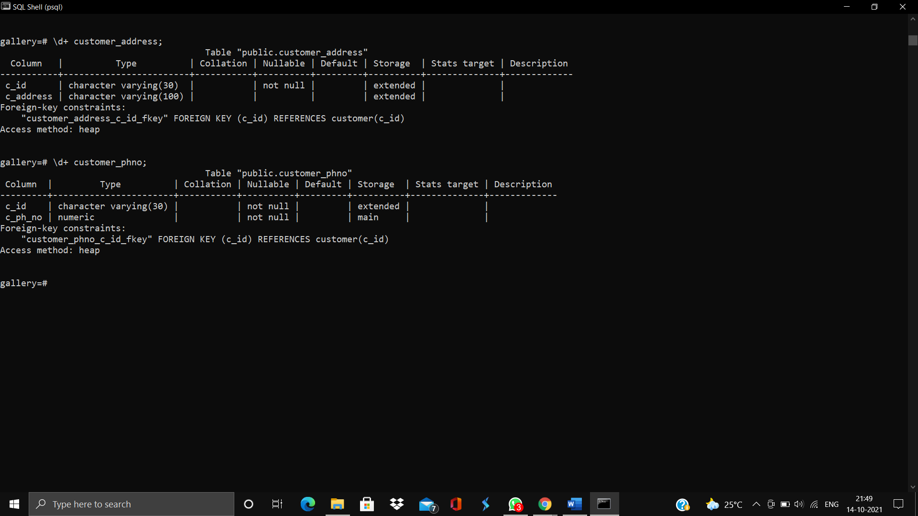

**Department:**

create table department(

d_no int unique not null primary key,

d_name varchar(40) not null unique,

head_id varchar(30) not null unique,

foreign key (head_id) references employee mgr_ssn));

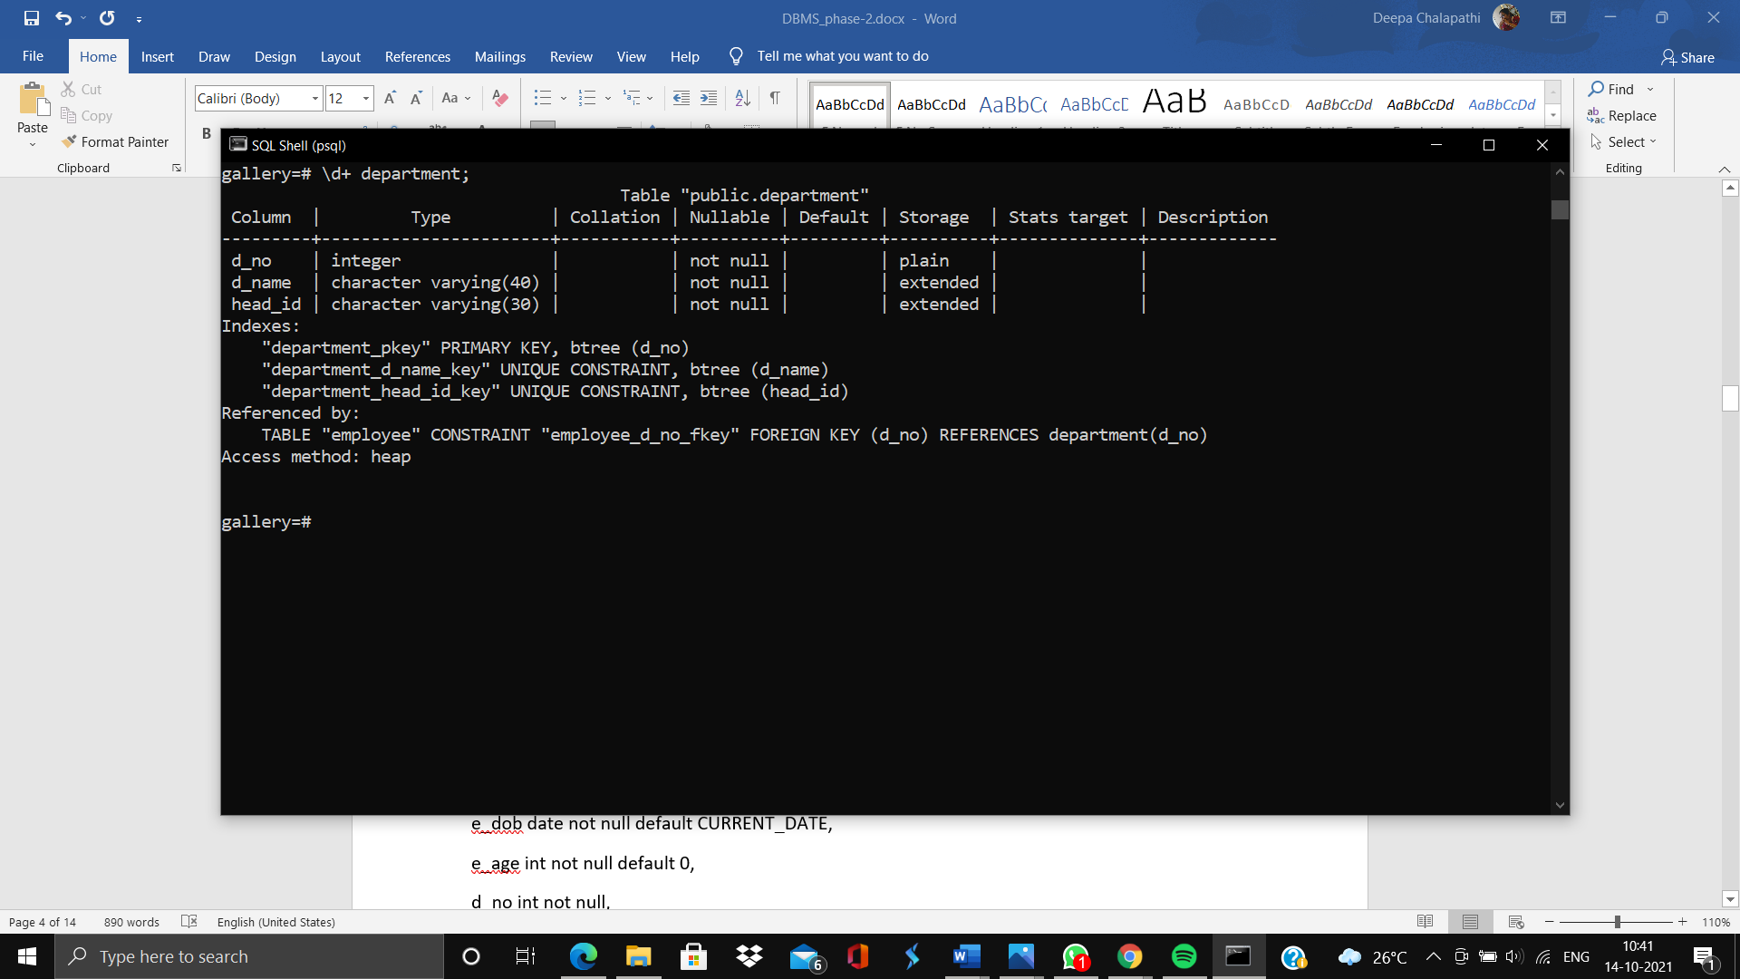

**Employee:**

create table employee(

e_id varchar(30) not null unique primary key,

e_fname varchar(30) not null default ‘None’,

e_mname varchar(30),

e_lname varchar(30) not null default ‘None’,

date_of_join date not null default CURRENT_DATE,

e_gender varchar(6) default ‘None’,

e_dob date not null default CURRENT_DATE,

e_age int not null default 0,

d_no int not null,

e_salary float not null default 0.0,

mgr_ssn varchar(30) not null,

foreign key(d_no) references department (d_no));

alter table employee add constraint check(age>=18);

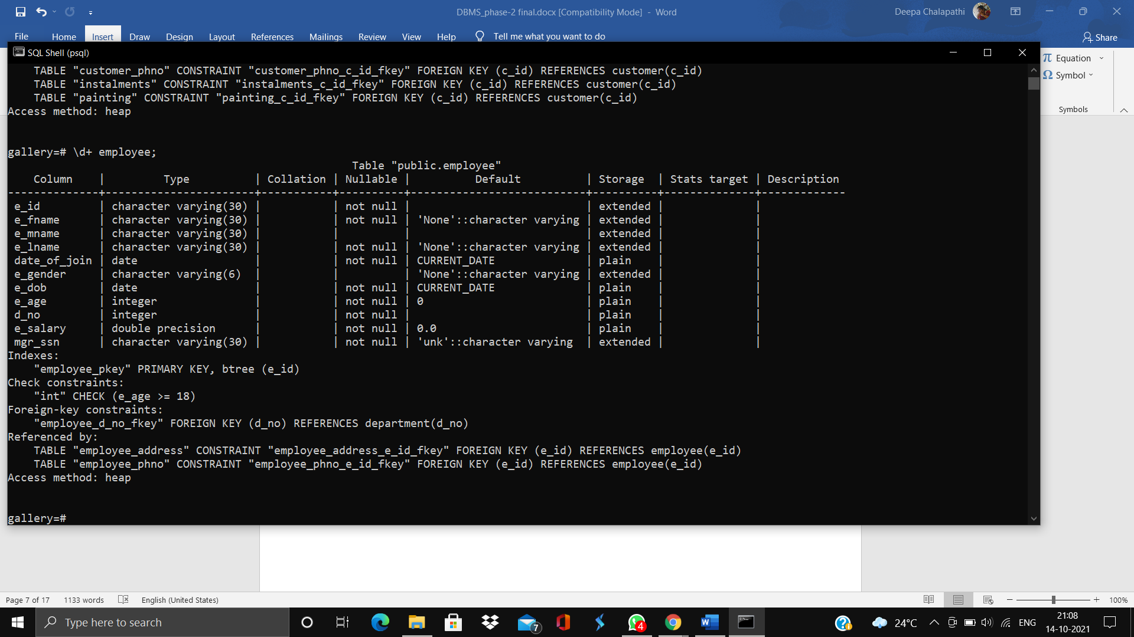

**Employee_address and Emplyee_phno:**

create table employee_address(

e_id varchar(30) not null unique,

e_address varchar(100),

foreign key (e_id) references employee(e_id));

create table employee_phno(

e_id varchar(30) not null unique,

e_ph_no numeric,

foreign key (e_id) references employee(e_id));

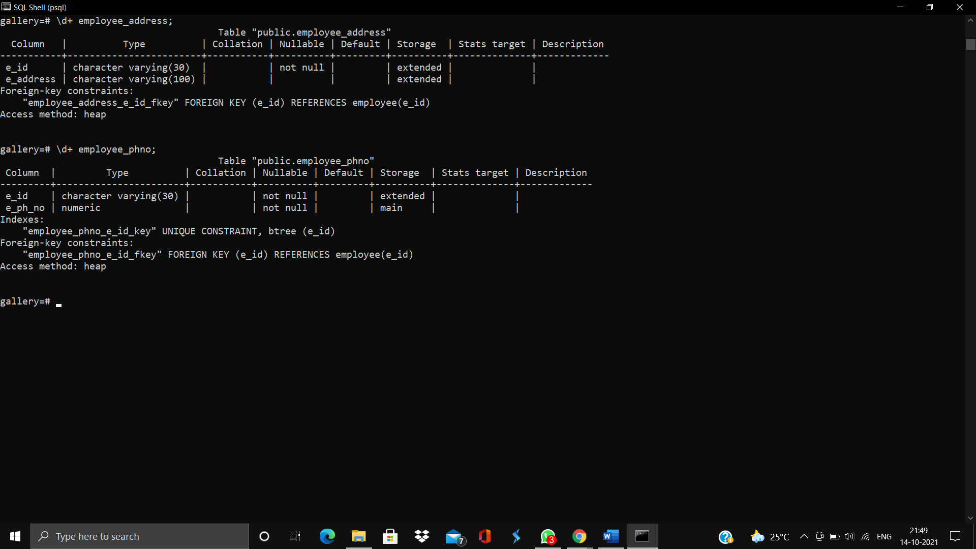

**Exhibited_in:**

create table exhibited_in(

ex_id not null,

p_id not null,

foreign key (ex_id) references exhibition (ex_id),

foreign key (p_id) references painting(p_id));

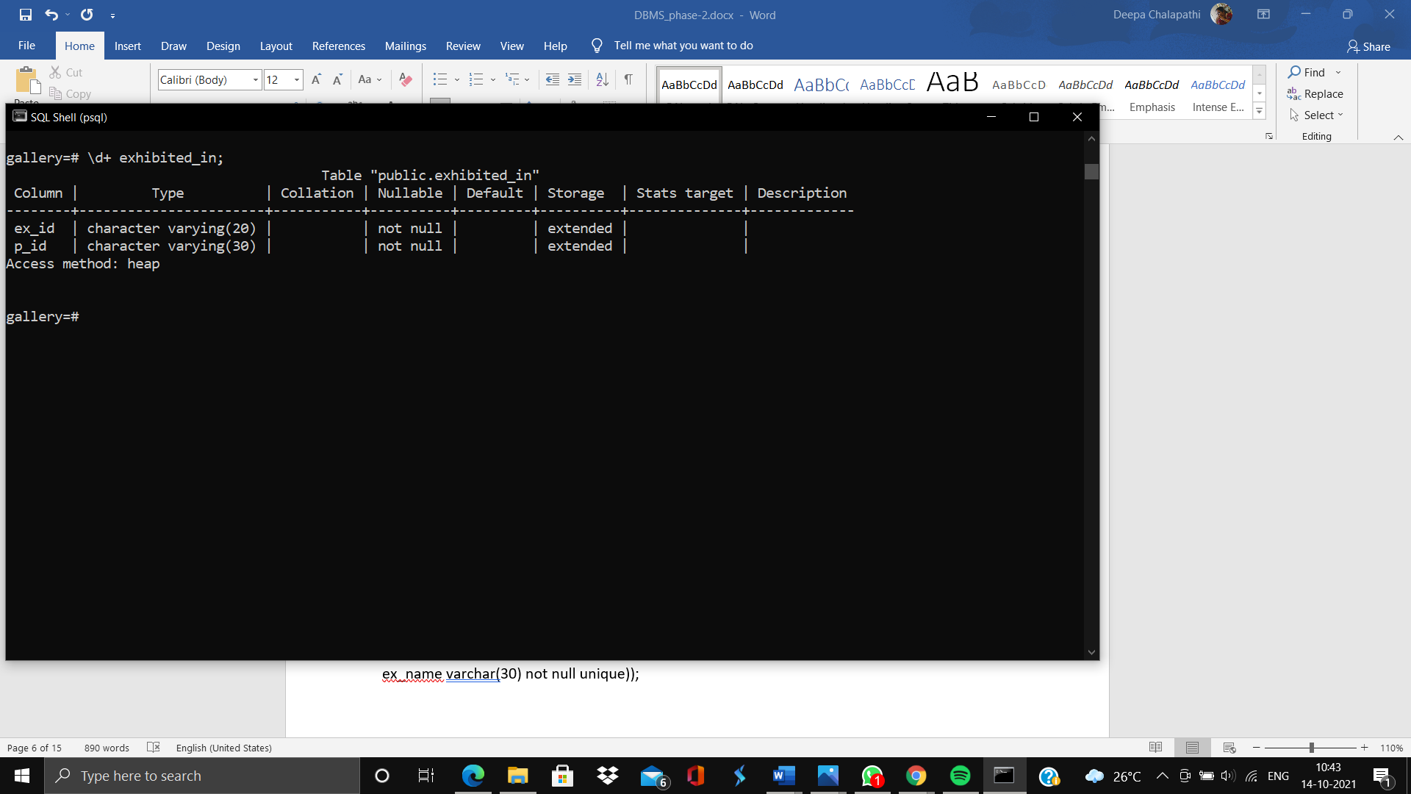

**Exhibition:**

create table exhibition(

ex_id varchar(20) not null unique;

ex_start_date date not null default CURRENT_DATE,

ex_end_date date not null default CURRENT_DATE,

ex_name varchar(30) not null unique));

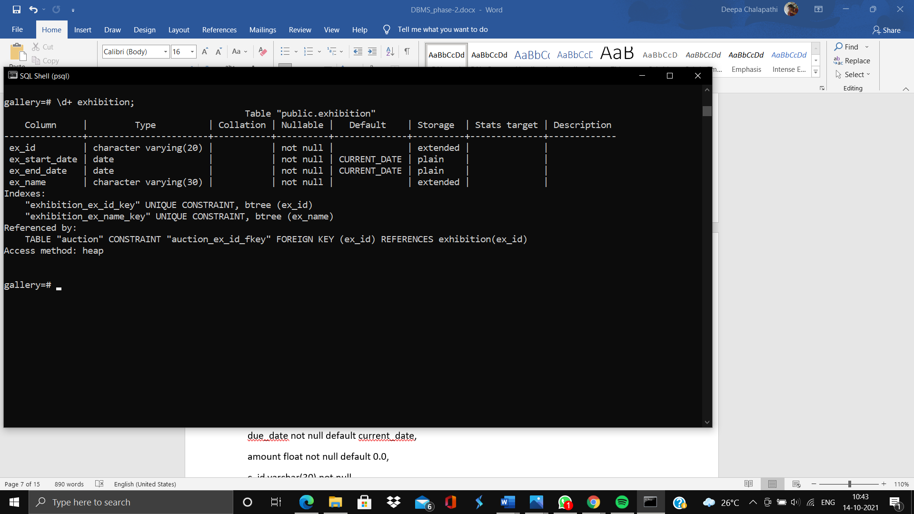

**Instalments:**

create table instalments(

i_no int not null default 0,

p_id not null,

pay_date date not null default current_date,

due_date not null default current_date,

amount float not null default 0.0,

c_id varchar(30) not null,

foreign key(p_id ) references painting(p_id),

foreign key(c_id) references customer(c_id));

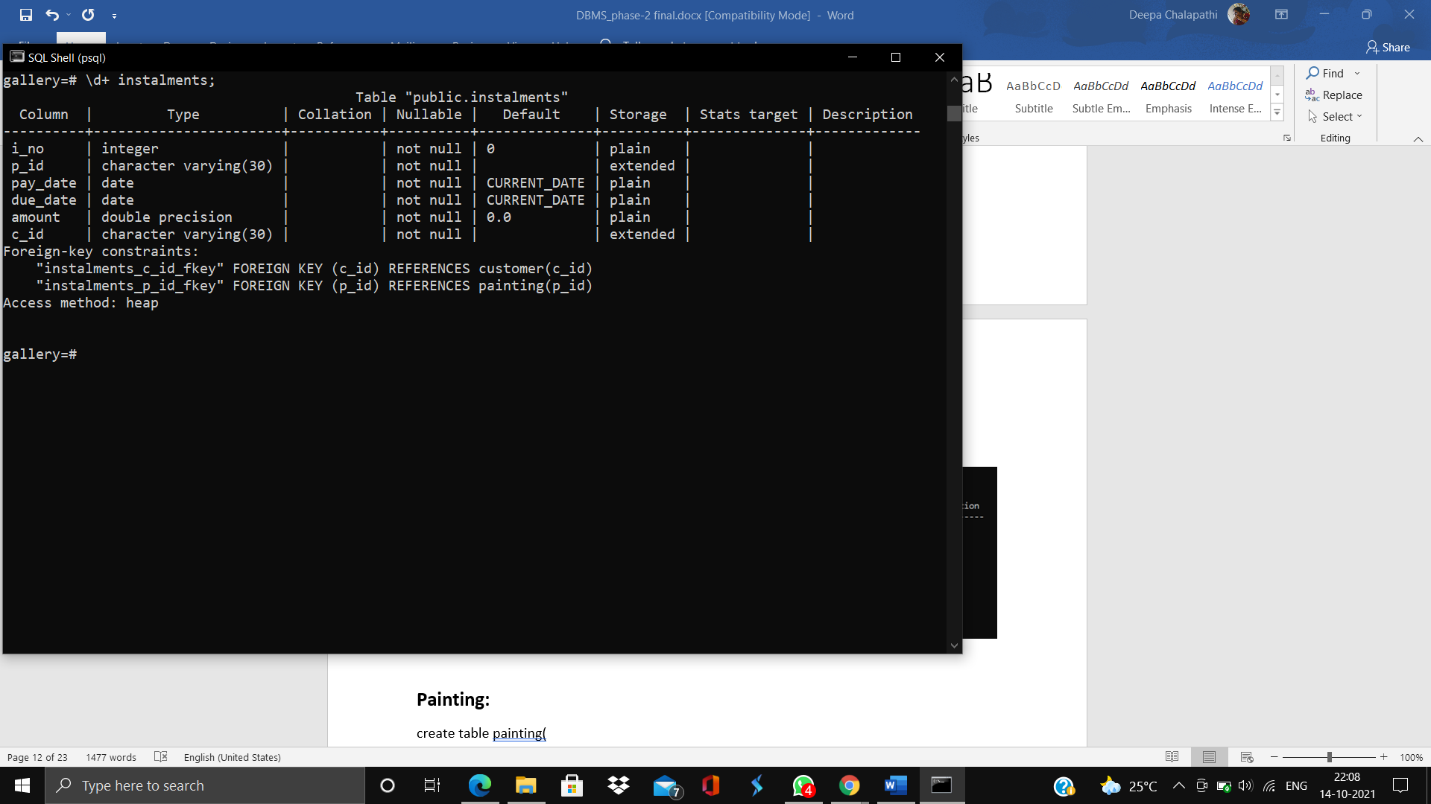

**Painting:**

create table painting(

p_id varchar(30) not null unique primary key,

p_name varchar(30) not null unique,

p_price float not null default 0.0,

a_id varchar(30) not null,

c_id varchar(30)

foreign key(a_id ) references artist(a_id),

foreign key(c_id) references customer(c_id));

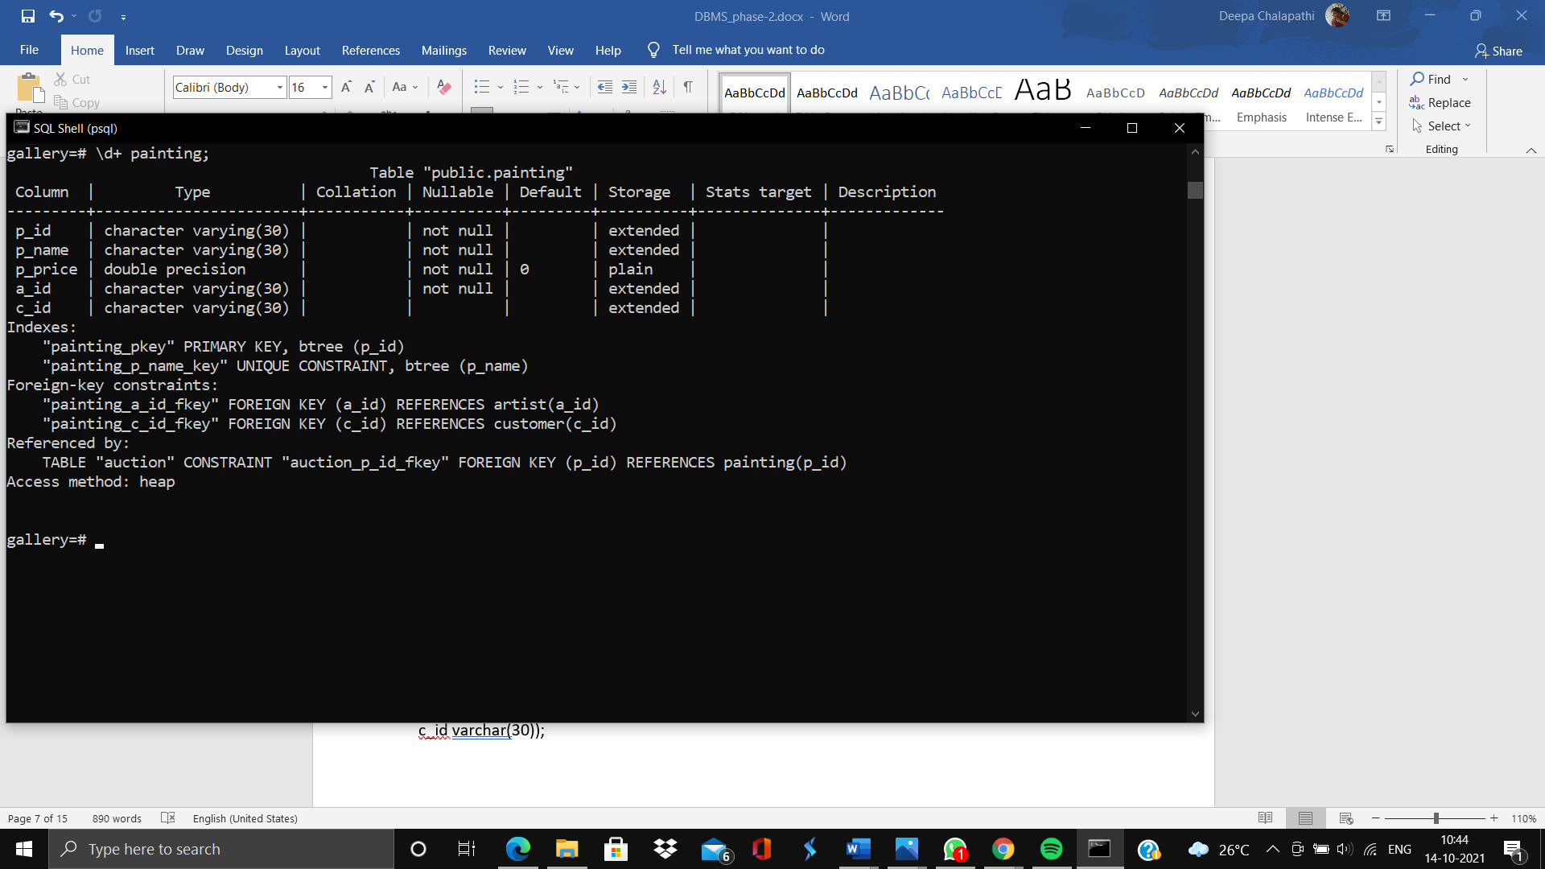

**Insert statements:**

**Artist:**

insert into artist values ('a1,'john','von','neumann','john@gmail.com', 'Male');

insert into artist values('a2','joanne','','wagner','joanne@gmail.com', 'Female');

insert into artist values('a3','karen','jane','baker','karen@gmail.com', 'Female');

insert into artist values ('a4','deekshitha','','sharma','deekshitha@gmail.com', 'Female');

insert into artist values('a5','seema','singha','fernandes','seema@gmail.com', 'Female');

insert into artist values('a6','kevin','thomas','mathew','kevin@gmail.com' ,'Male');

insert into artist values('a7','karen','diane','jensen','emma@gmail.com', 'Female');

insert into artist values('a8','Edward','willis','jensen','edward@gmail.com', 'Male');

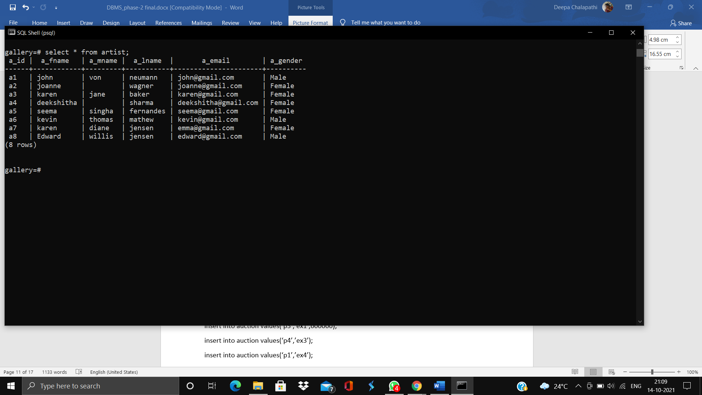

**Artist_address:**

insert into artist_address values(‘a1’,'432,Parkview Avenue,London');

insert into artist address values(‘a2’,’ '#52,Baker street,LA');

insert into artist_address values(‘a3’);

insert into artist_address values(‘a4’,'#852,RedFort Road,Delhi’);

insert into artist_address values(‘a5’,’ #673 Booker Street,NYC’);

insert into artist_address values(‘a6’,’ #82,MG Road,Bangalore’);

insert into artist_address values(‘a7’,’#998,Bandra,Mumbai’);

insert into artist address,values(‘a8’,’#998,Langdown Town, Seoul’);

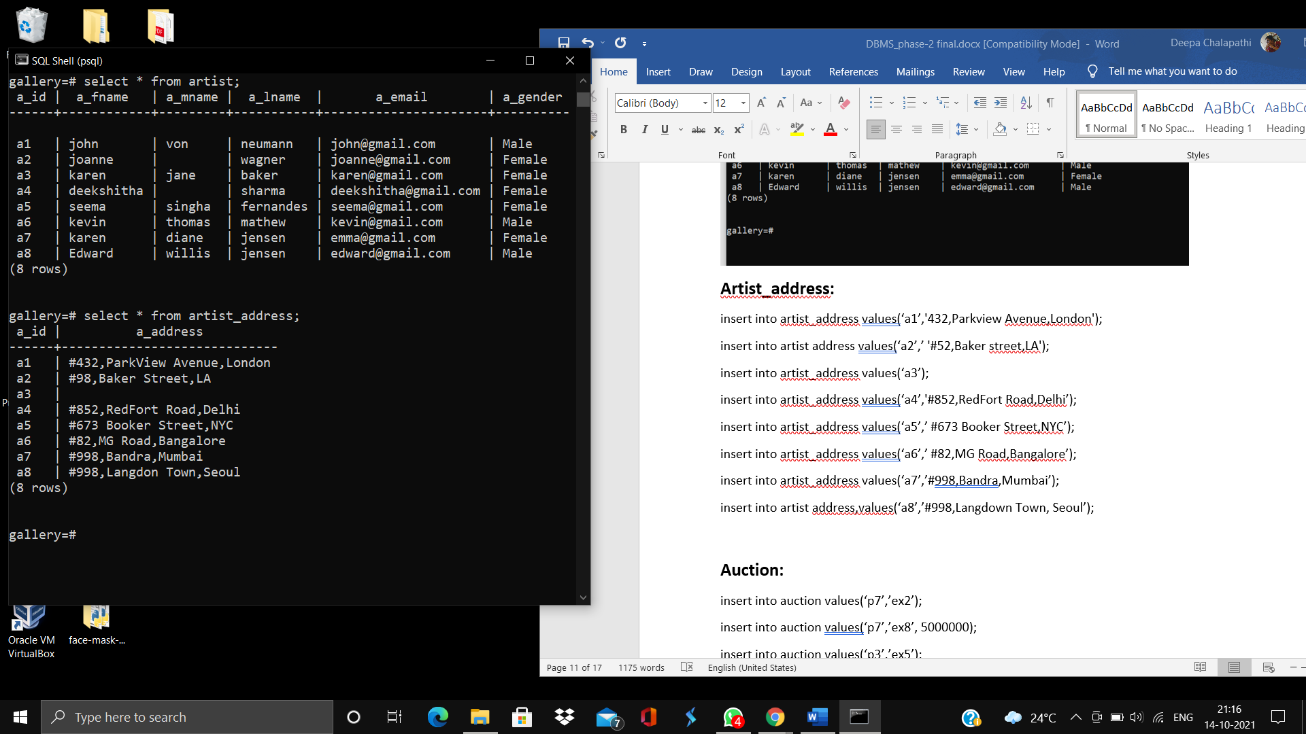

**Artist_phno:**

insert into artist_phno values(‘a1’, 9801234567);

insert into artist_phno values(‘a2’, 9087654310);

insert into artist_phno values(‘a3’, 8901234567);

insert into artist_phno values(‘a4’, 9123450679);

insert into artist_phno values(‘a5’, 9087654123);

insert into artist_phno values(‘a6’, 8756091237);

insert into artist_phno values(‘a7’, 8756091237);

insert into artist_phno values(‘a8’, 9087451236);

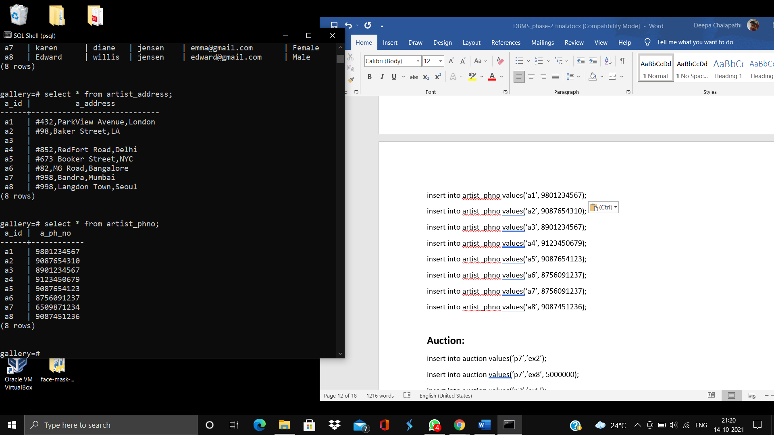

**Auction:**

insert into auction values(‘p7’,’ex2’);

insert into auction values(‘p7’,’ex8’, 5000000);

insert into auction values(‘p3’,’ex5’);

insert into auction values(‘p2’,’ex7’,1000000);

insert into auction values(‘p3’,’ex1’,600000);

insert into auction values(‘p4’,’ex3’);

insert into auction values(‘p1’,’ex4’);

insert into auction values(‘p8’,’ex6’,8760000);

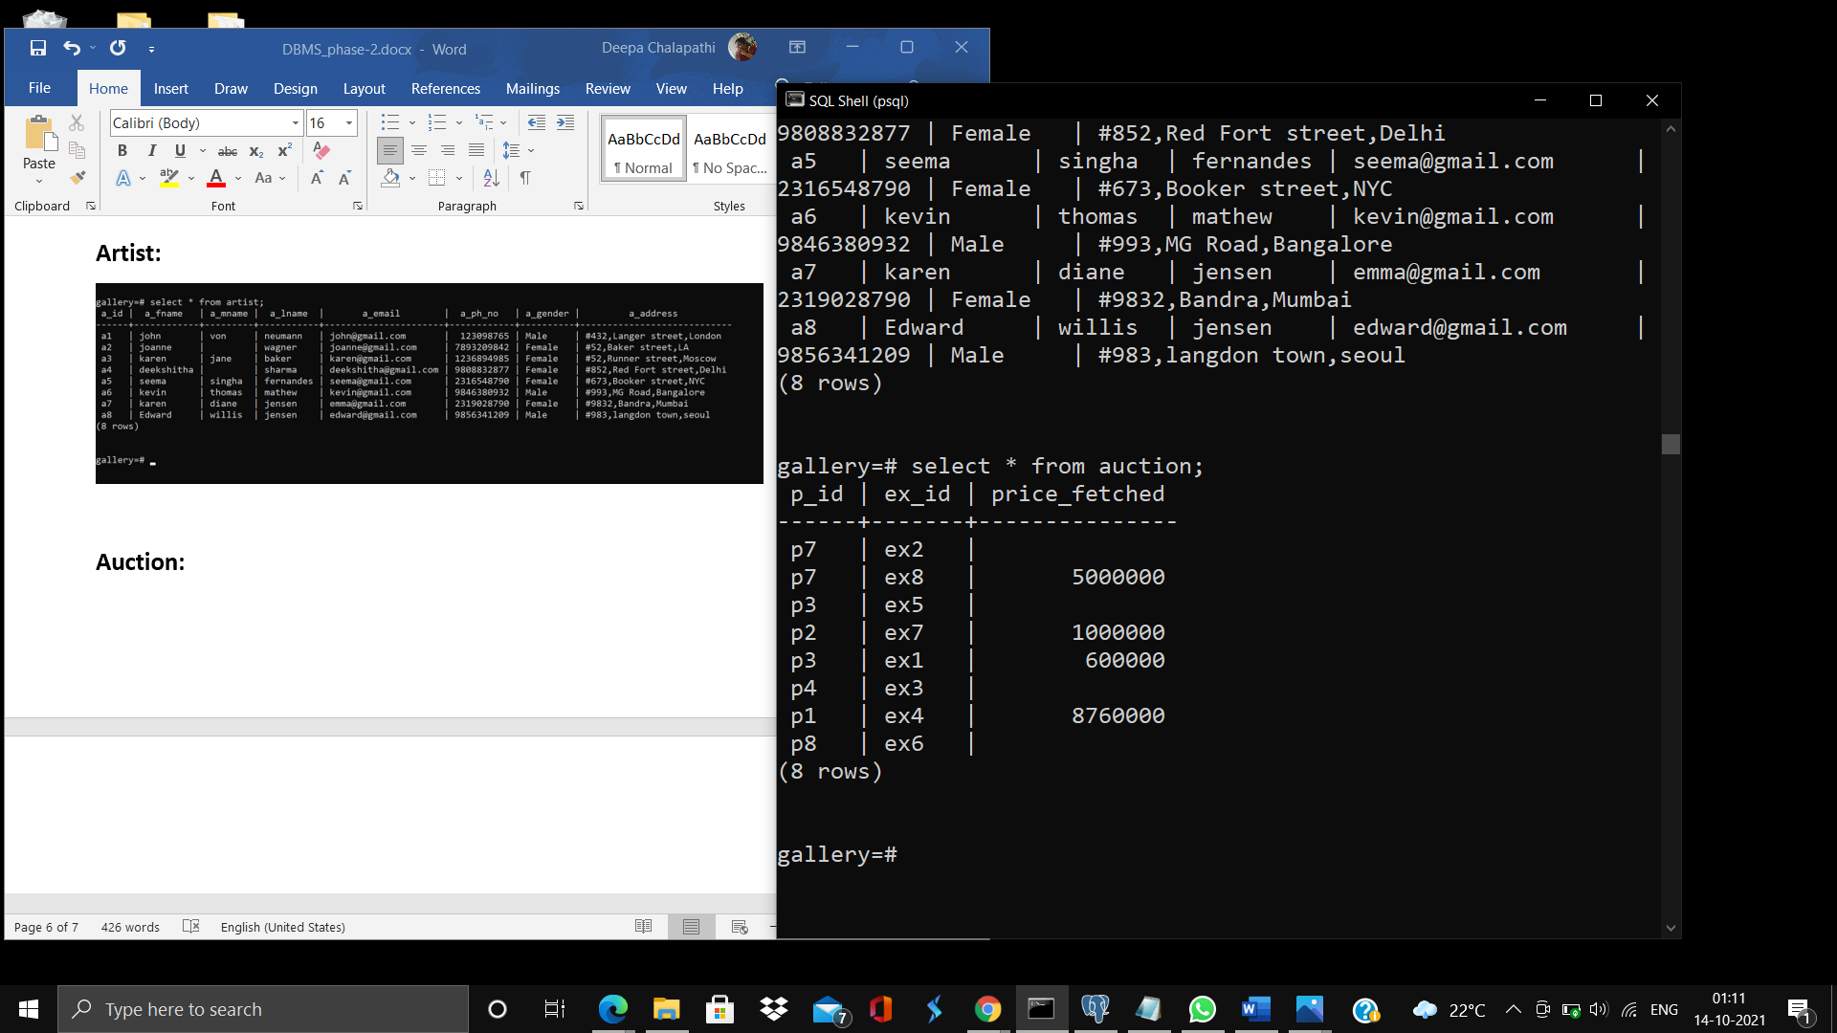

**Customer:**

insert into customer values('c1','maddie',NULL,'gomez','maddie@hotmail.com','Female');

insert into customer values('c2','niels','atom','bohr','niel@hotmail.com','Male');

insert into customer values('c3','ariana','grande','butera','thunderbolt@gmail.com','Male');

insert into customer values('c4','anamika','','khan','ann@gmail.com', 'Female');

insert into customer values('c5','james','','cerbero,'james@gmail.com', 'Male');

insert into customer values('c6','jengis','','khan','jengis@gmail.com', 'Male','');

insert into customer values('c7','carol','peter','rumero','helloworld@yahoo.com');

insert into customer values('c8','napolean','hansel','hingis','napole@gmail.com', 'Male');

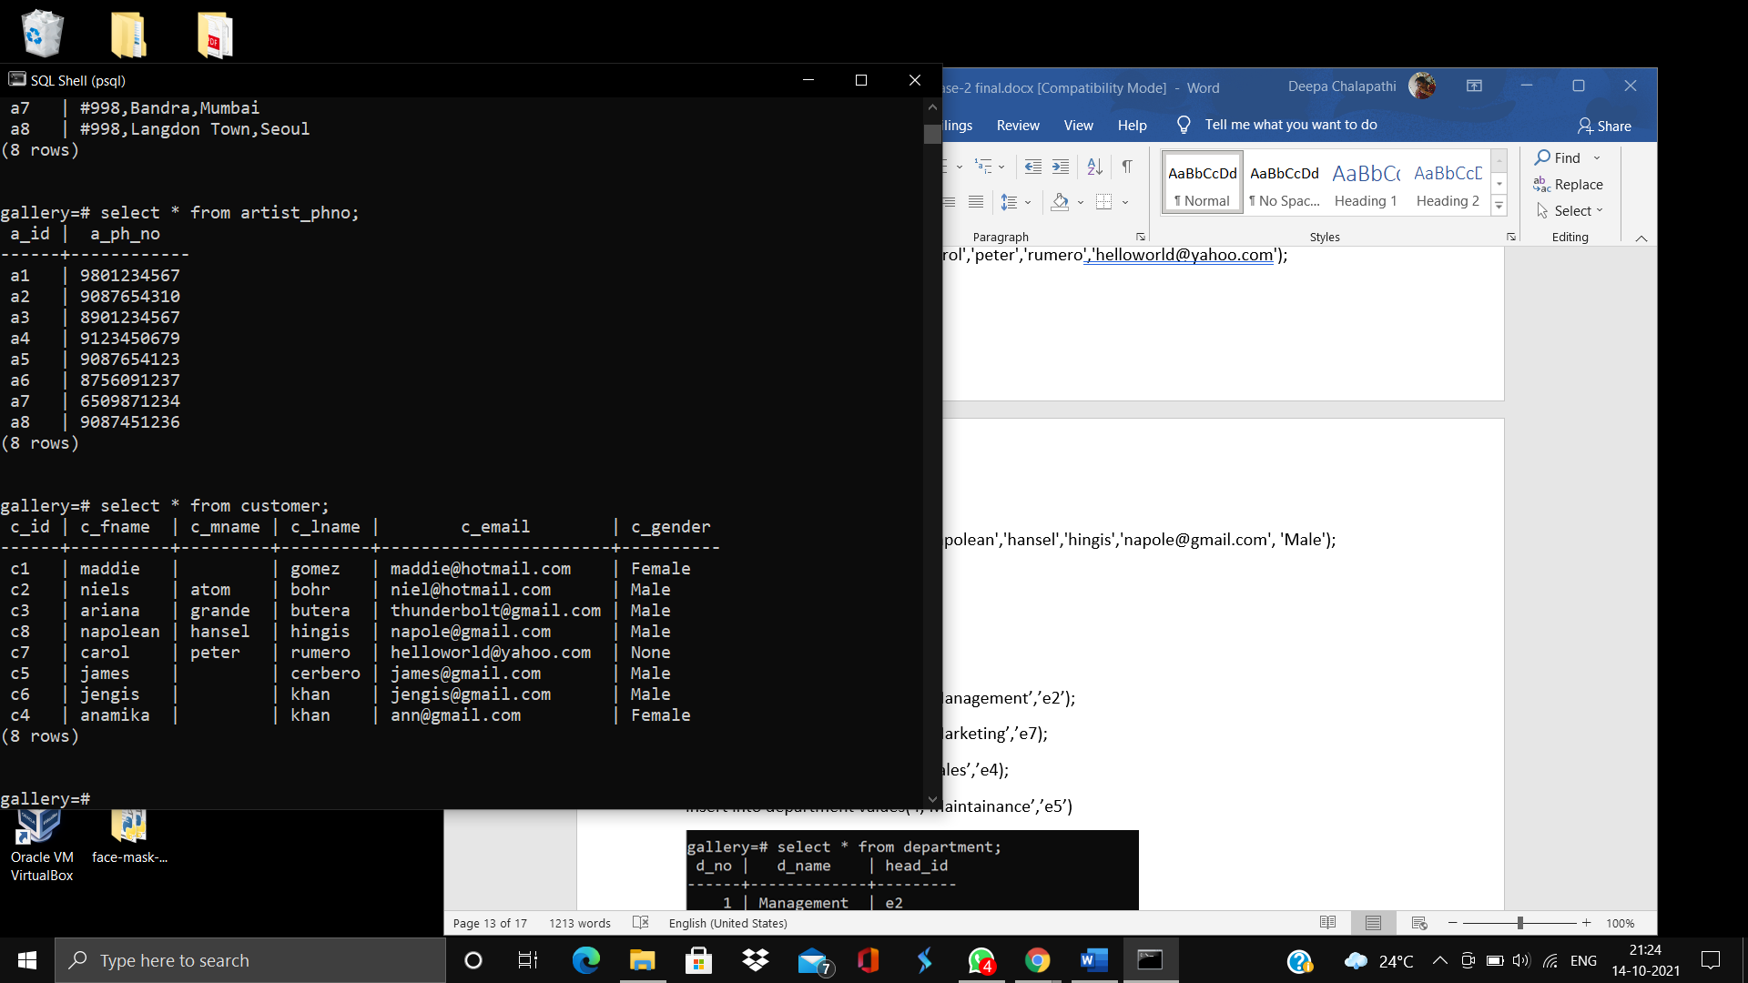

**Customer_address:**

insert into customer_address values(‘c1’);

insert into customer_address values(‘c2’, ‘#583,street,alabama’);

insert into customer_address values(‘c3’,’ #457,7th street,NewJersey’);

insert into customer_address values(‘c4’,’ #49,church street,NYC’);

insert into customer_address values(‘c5’,’ #984,Morata Street Madrid’);

insert into customer_address values(‘c6’);

insert into customer_address values(‘c7’);

insert into customer_address values(‘c8’,’ #123,Doll street, Tokyo’);

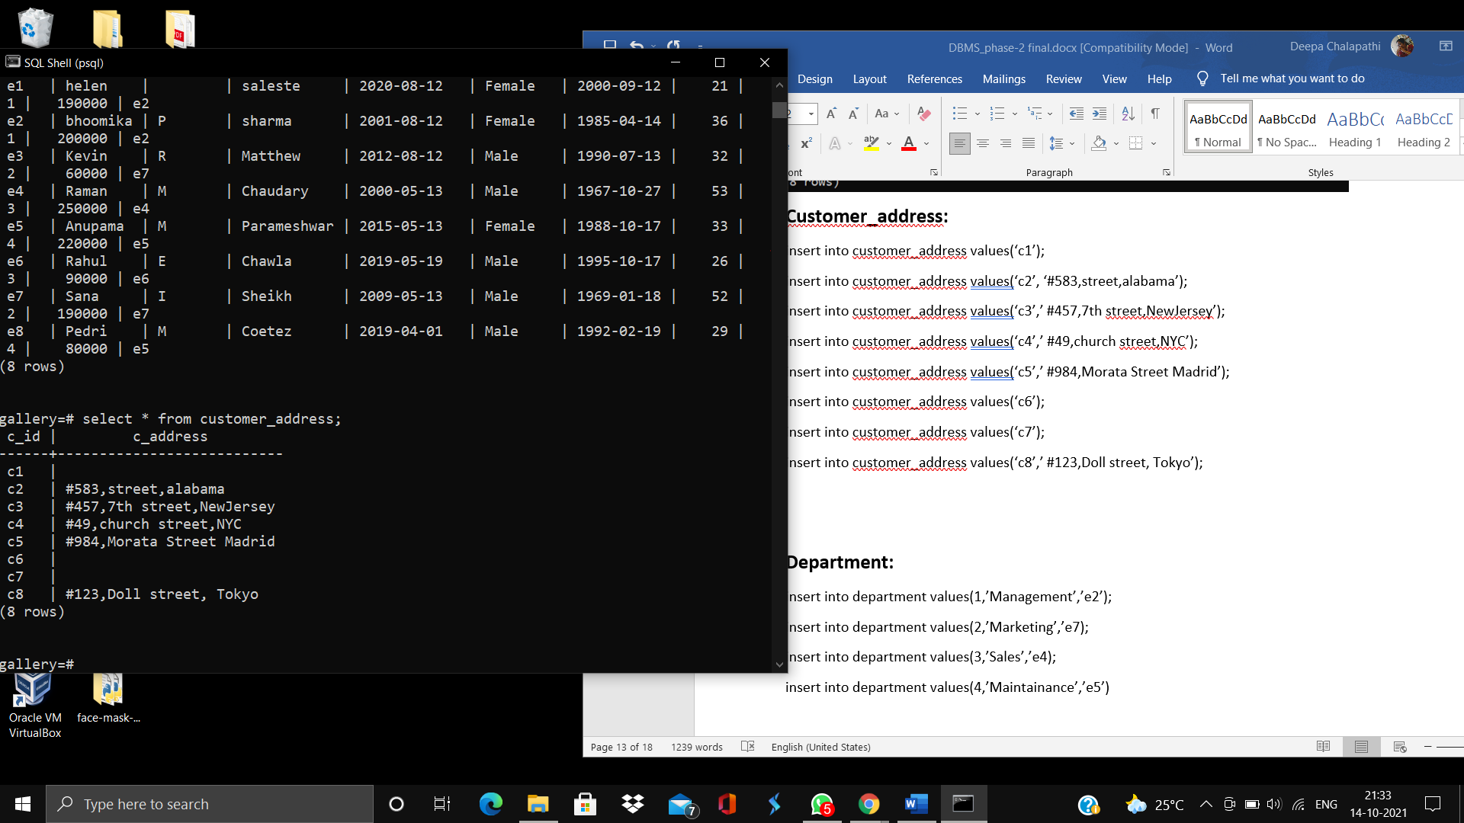

**Customer_phno:**

insert into customer_phno values(‘c1’, 987654321);

insert into customer_phno values(‘c2’, 9083421091);

insert into customer_phno values(‘c3’, 9879309872);

insert into customer_phno values(‘c4’, 1234567890);

insert into customer_phno values(‘c5’, 9867542310);

insert into customer_phno values(‘c6’, 8967452310);

insert into customer_phno values(‘c7’, 6789012345);

insert into customer_phno values(‘c8’, 789012345);

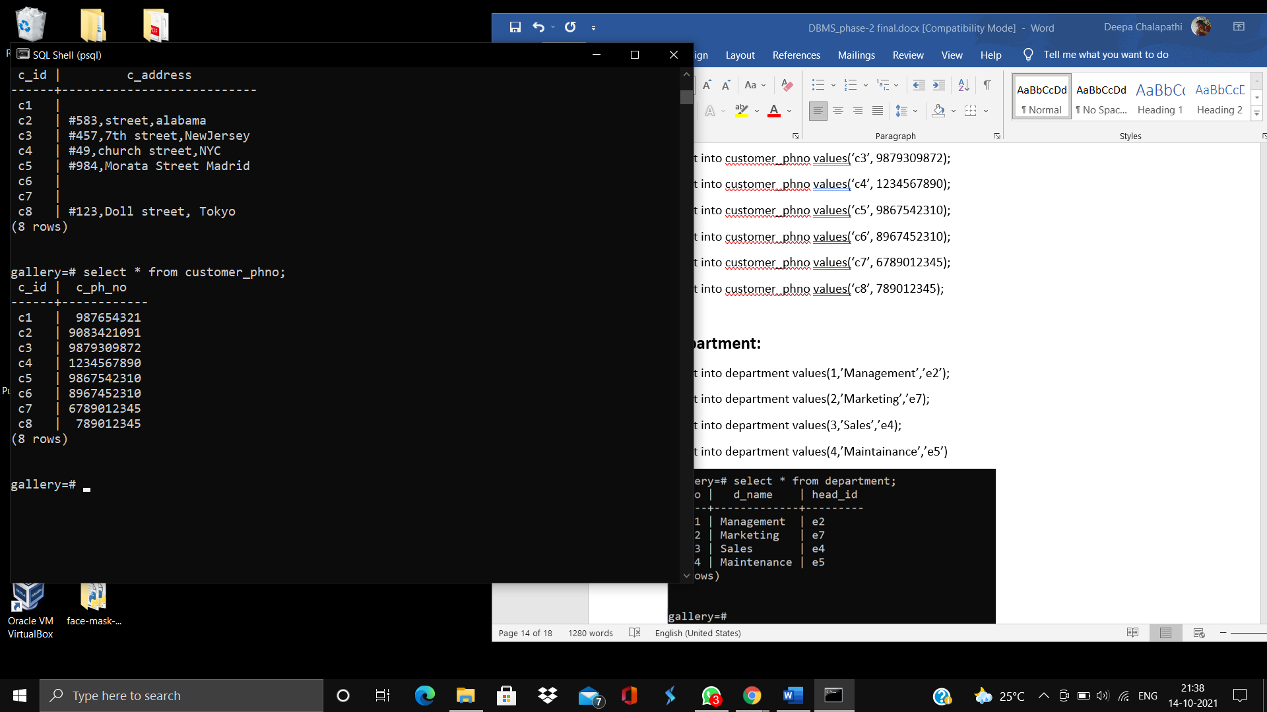

**Department:**

insert into department values(1,’Management’,’e2’);

insert into department values(2,’Marketing’,’e7);

insert into department values(3,’Sales’,’e4);

insert into department values(4,’Maintainance’,’e5’)

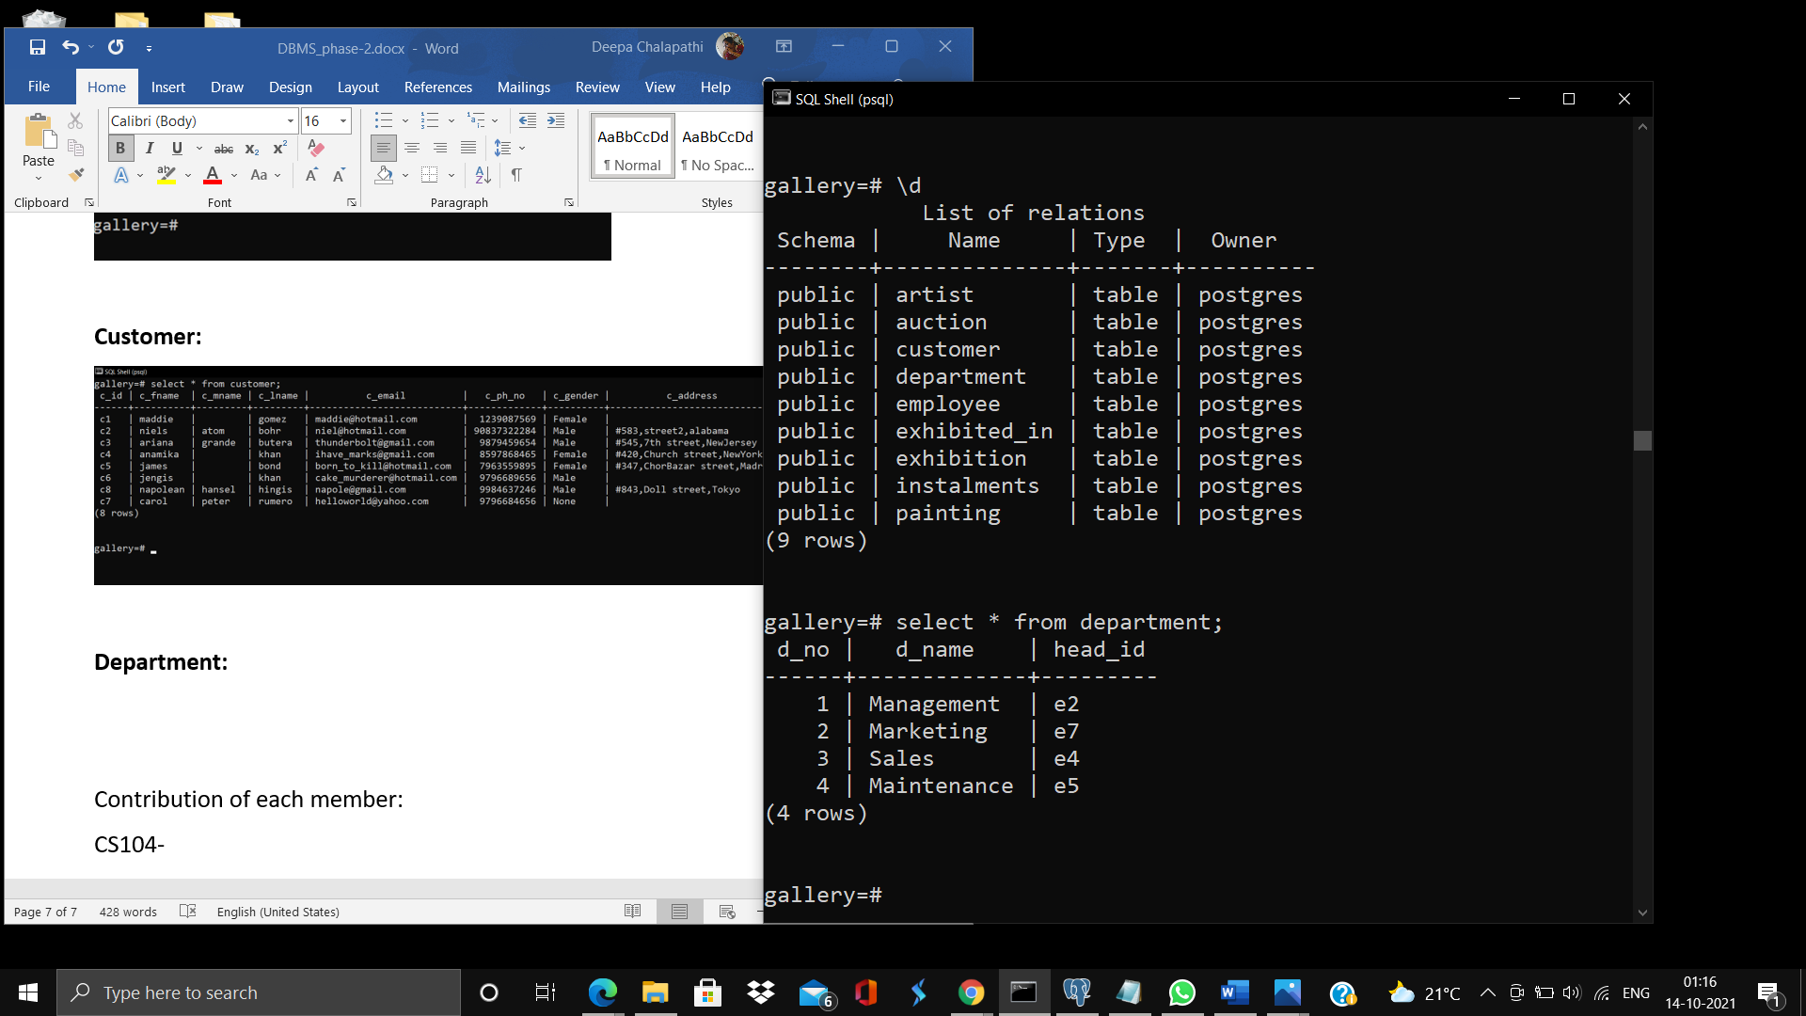

**Employee:**

insert into employee values('e1','helen','','saleste','12-08-2020','Female','12-9-2000',21,01,190000,’e2’);

insert into employee values(‘e2’,’bhoomika’,’P’,’sharma’,’2001-08-12’,’female,36,1,200000,’e2’);

insert into employee values(‘e3’,‘Kevin ‘,’R ‘,‘Matthew ‘,‘2012-08-12’,’ Male ‘,’1990-07-13’, 32, 2 ,60000,‘e7’)

insert into employee values(e4, ‘Raman ‘,‘M’, ‘Chaudary’, ‘2000-05-13 ‘,‘Male,’1967-10-27’, 53,3 ,250000 , ‘e4’)

insert into employee values(‘e5‘,‘Anupama’ ,‘M ‘,‘Parameshwar’,’2015-05-13’,‘Female’,‘1988-10-17 ‘,33 ,4 ,220000,‘e5’);

insert into employee values (‘e6 ‘,‘Rahul’,‘E ‘,‘Chawla’,‘2019-05-19 ‘,‘Male’,‘1995-10-17’, 26 ,3, 90000, ‘e6’);

inset into employee values(‘e7 ,’Sana,’I’ , ‘Sheikh’ ,’2009-05-13’,‘Male’ ,‘1969-01-18’ ,52,2, 190000, ‘e7’);

insert into employee values(‘e8’ , ‘Pedri’,‘M’ ,‘Coetez’ ,‘2019-04-01’,‘Male ‘,1992-02-19, 29,4,80000, ‘e5’);

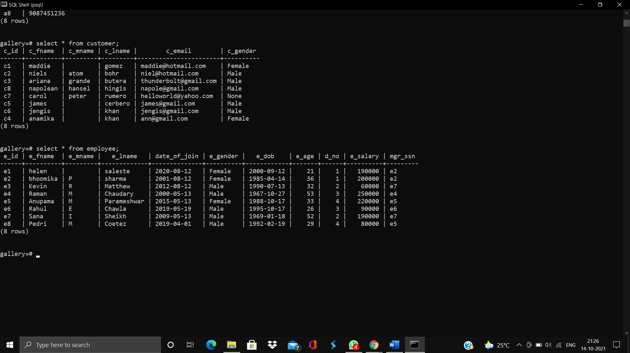

**Employee_address:**

insert into employee_address values(‘e1’,’ #456,Langdon town, Bangalore’);

insert into employee_address values(‘e2’,’ #46,Richmond Circle, Bangalore’);

insert into employee_address values(‘e3’,’ #189,MG Road,Bangalore’);

insert into employee_address values(‘e4’,’ #289,Malleshwaram,Bangalore’);

insert into employee_address values(‘e5’,’ #45,Jayanagar,Bangalore’);

insert into employee_address values(‘e6’,’ #91,JP Nagar,Bangalore’);

insert into employee_address values(‘e7’,’ #109,Kormanagala,Bangalore’);

insert into employee_address values(‘e8’,’ #760,Shivajinagar,Bangalore’);

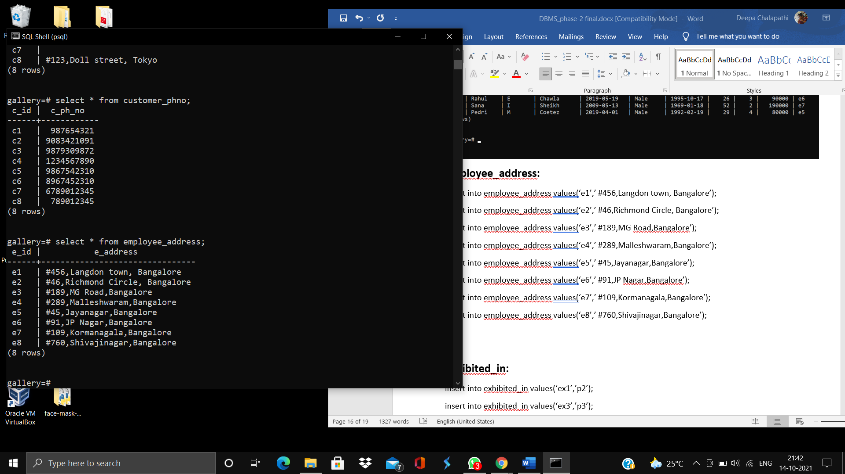

**Employee_phno:**

insert into employee_phno values(‘e1’, 9876543210);

insert into employee_phno values(‘e2’, 9038372999);

insert into employee_phno values(‘e3’, 8897655432);

insert into employee_phno values(‘e4’, 6789012345);

insert into employee_phno values(‘e5’, 9087564321);

insert into employee_phno values(‘e6’, 9987654320);

insert into employee_phno values(‘e7’, 9876540123);

insert into employee_phno values(‘e8’, 7890123456);

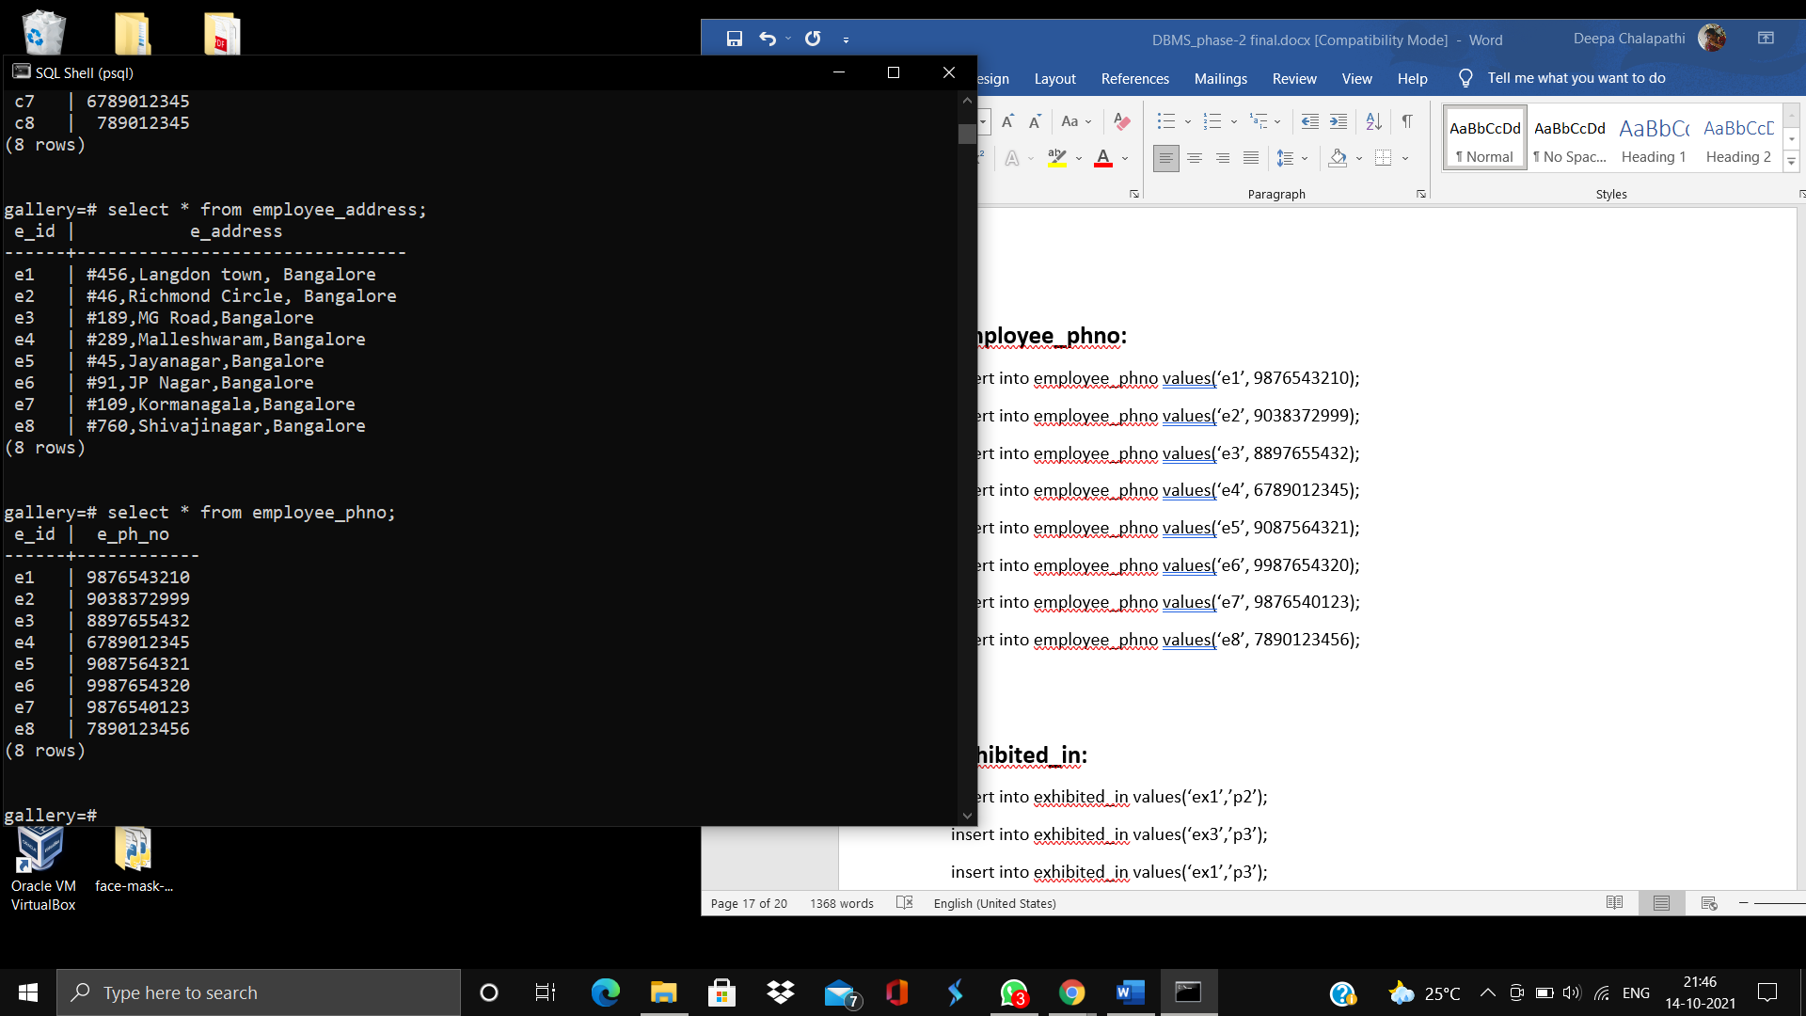

**Exhibited_in:**

insert into exhibited_in values(‘ex1’,’p2’);

insert into exhibited_in values(‘ex3’,’p3’);

insert into exhibited_in values(‘ex1’,’p3’);

insert into exhibited_in values(‘ex3’,’p4’);

insert into exhibited_in values(‘ex7,’p5’);

insert into exhibited_in values(‘ex7’,’p8’);

insert into exhibited_in values(‘ex6’,’p2’);

insert into exhibited_in values(‘ex5’,’p7’);

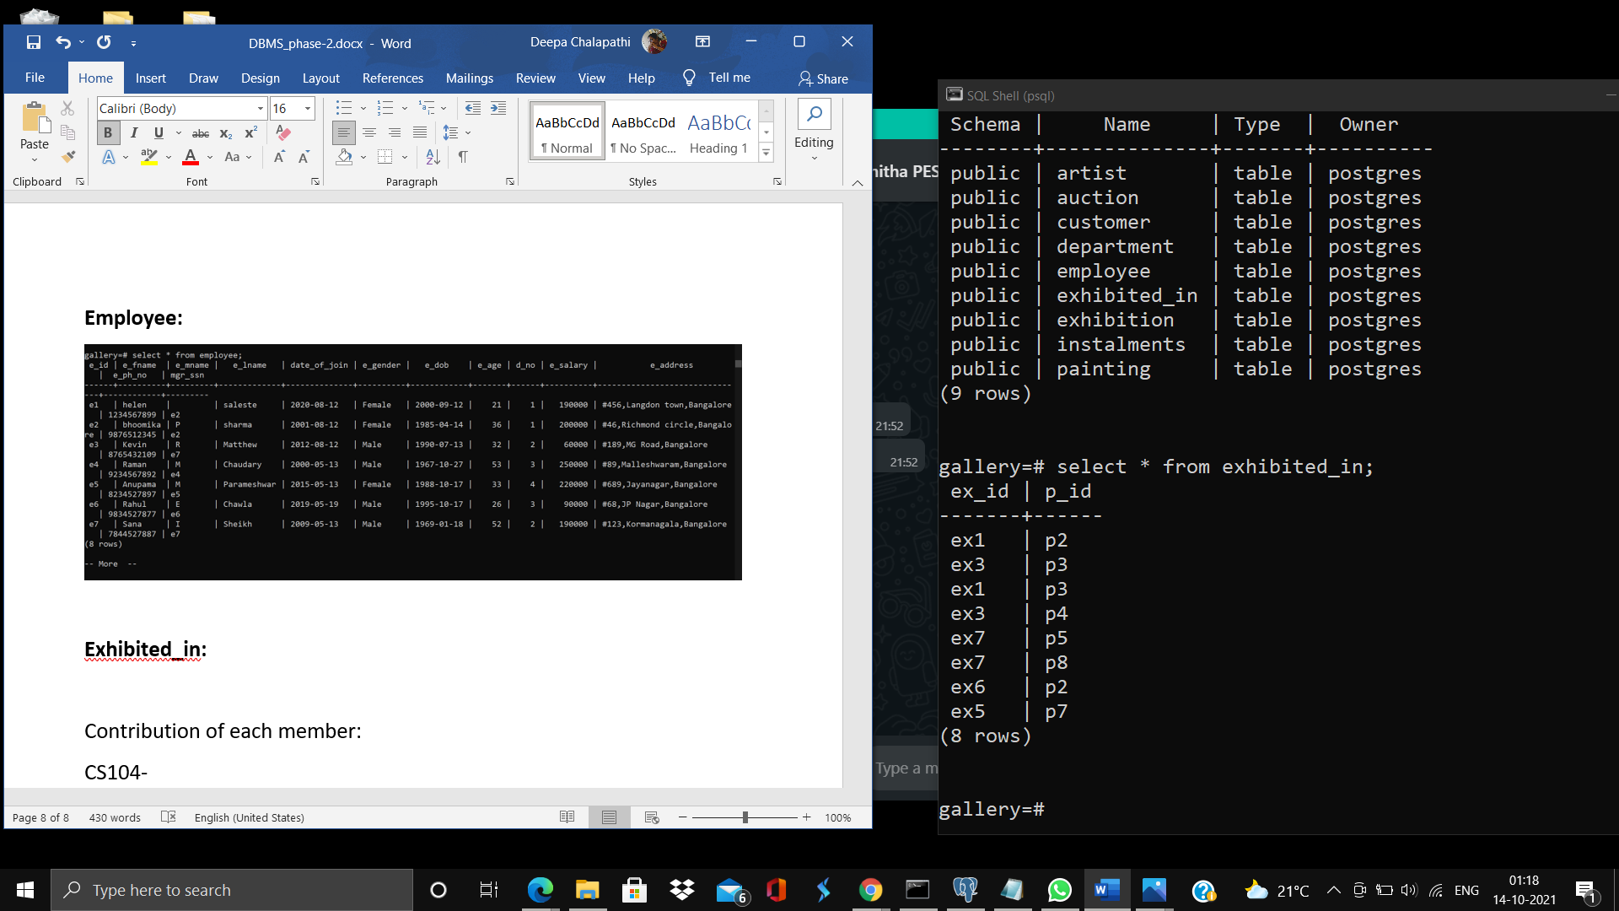

**Exhibition:**

insert into exhibition values('ex1','12-02-2019','14-02-2019','Nature and the Wild');

insert into exhibition values('ex2','12-08-2014','19-08-2014','Firing rage');

insert into exhibition values('ex3','20-01-2020','23-01-2020','View of the mind');

insert into exhibition values('ex4','17-03-2021','23-03-2021','Fly low');

insert into exhibition values('ex5','04-07-2020','07-07-2020','Beautiful Lies');

insert into exhibition values('ex6','04-06-2018','08-06-2018','Hues of the Heart');

insert into exhibition values('ex7','13-04-2019','17-04-2019','Blank Minds');

insert into exhibition values('ex8','7-05-2017','7-05-2017','The dead drop era');

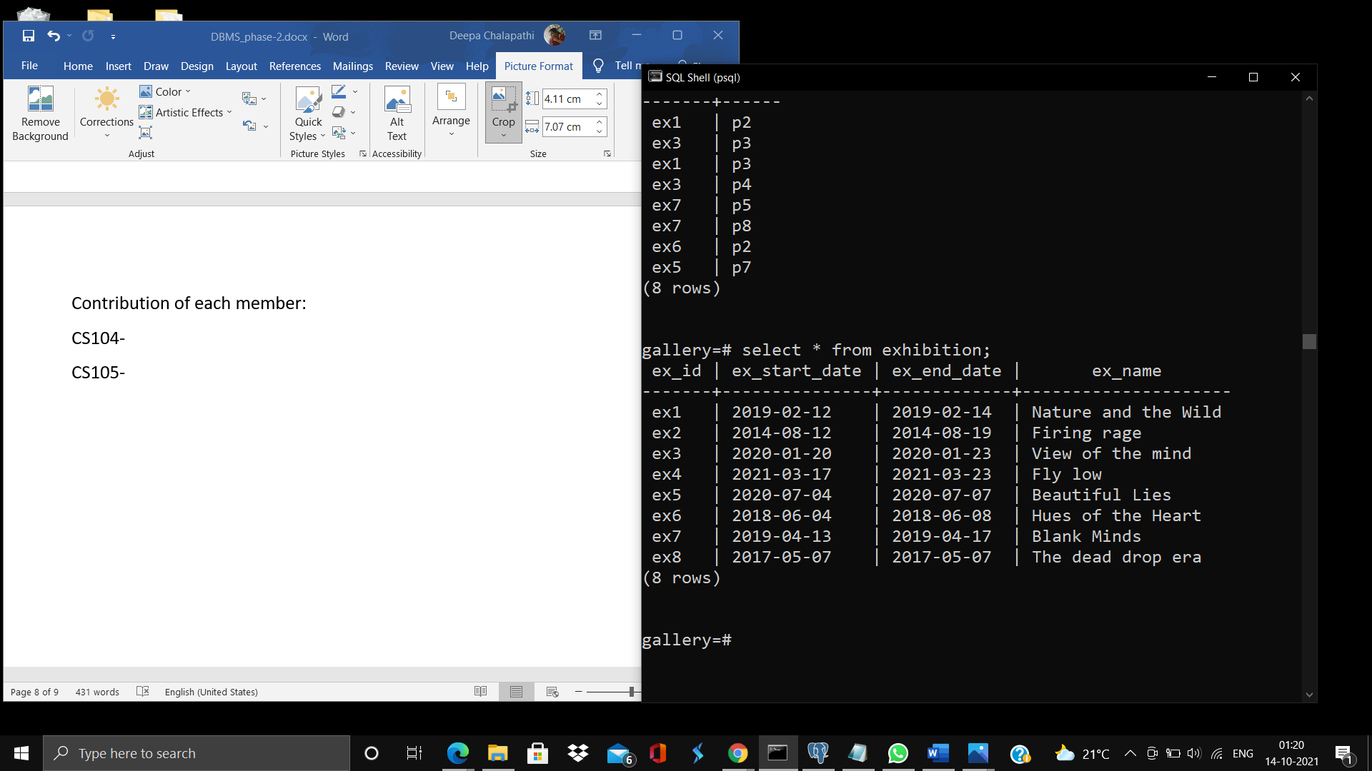

**Instalments:**

insert into instalments values(1,'p1','12-02-2019','14-02-2019',10000,'c3');

insert into instalments values(2,'p1','14-02-2019','14-03-2019',10000,'c3');

insert into instalments values(1,'p5','17-07-2021','17-05-2021',30000.98,'c8');

insert into instalments values(2,'p7','14-06-2020','18-07-2020',15000,'c7');

insert into instalments values(1,'p7','14-05-2020','18-06-2020',15000,'c7');

insert into instalments values(1,'p3','24-06-2020','18-07-2020',450000,'c4');

insert into instalments values(2,'p3','27-07-2020','18-08-2020',450000,'c4');

insert into instalments values(3,'p3','31-08-2020','18-09-2020',34983,'c4');

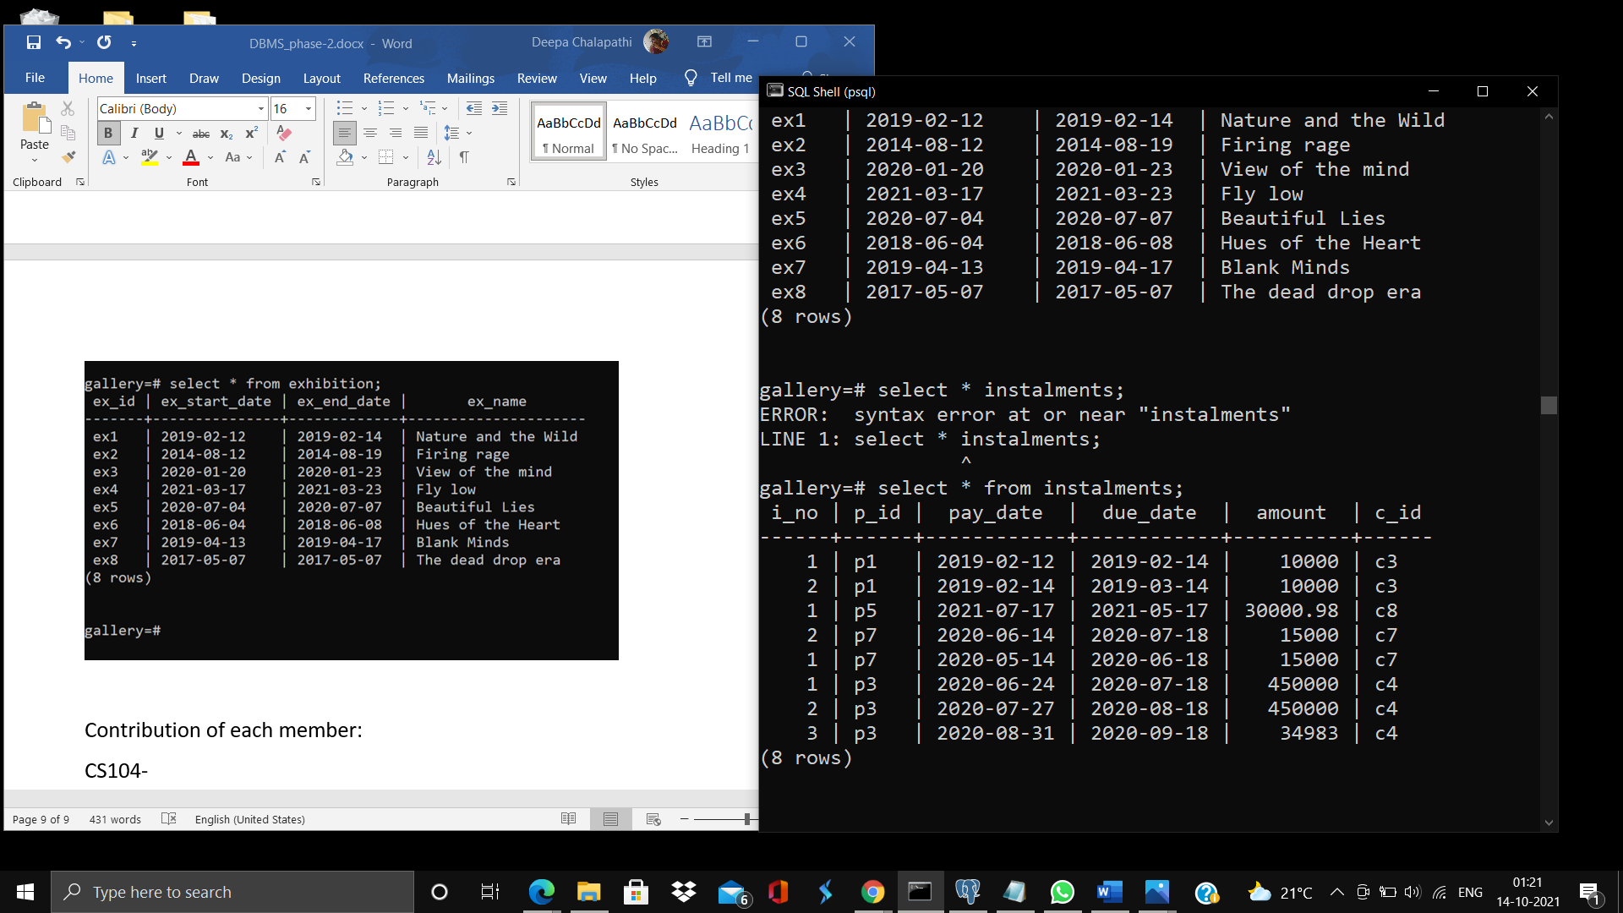

**Painting:**

insert into painting values('p1','sulking river',120000,'a2','c3');

insert into painting values('p2','the imperfectly perfect',120000,'a2','c4');

insert into painting values('p3','world though this eyes',934983,'a5','c4');

insert into painting values('p4','world without me',999999.99,'a6','c5');

insert into painting values('p5','moves like jagger',198295.643,'a1','c8');

insert into painting values('p6','STAY',69696969.69,'a4','c4');

insert into painting values('p7','my view',75587686,'a3','c7');

insert into painting values('p8','into the wild',345678,'a5','c3');

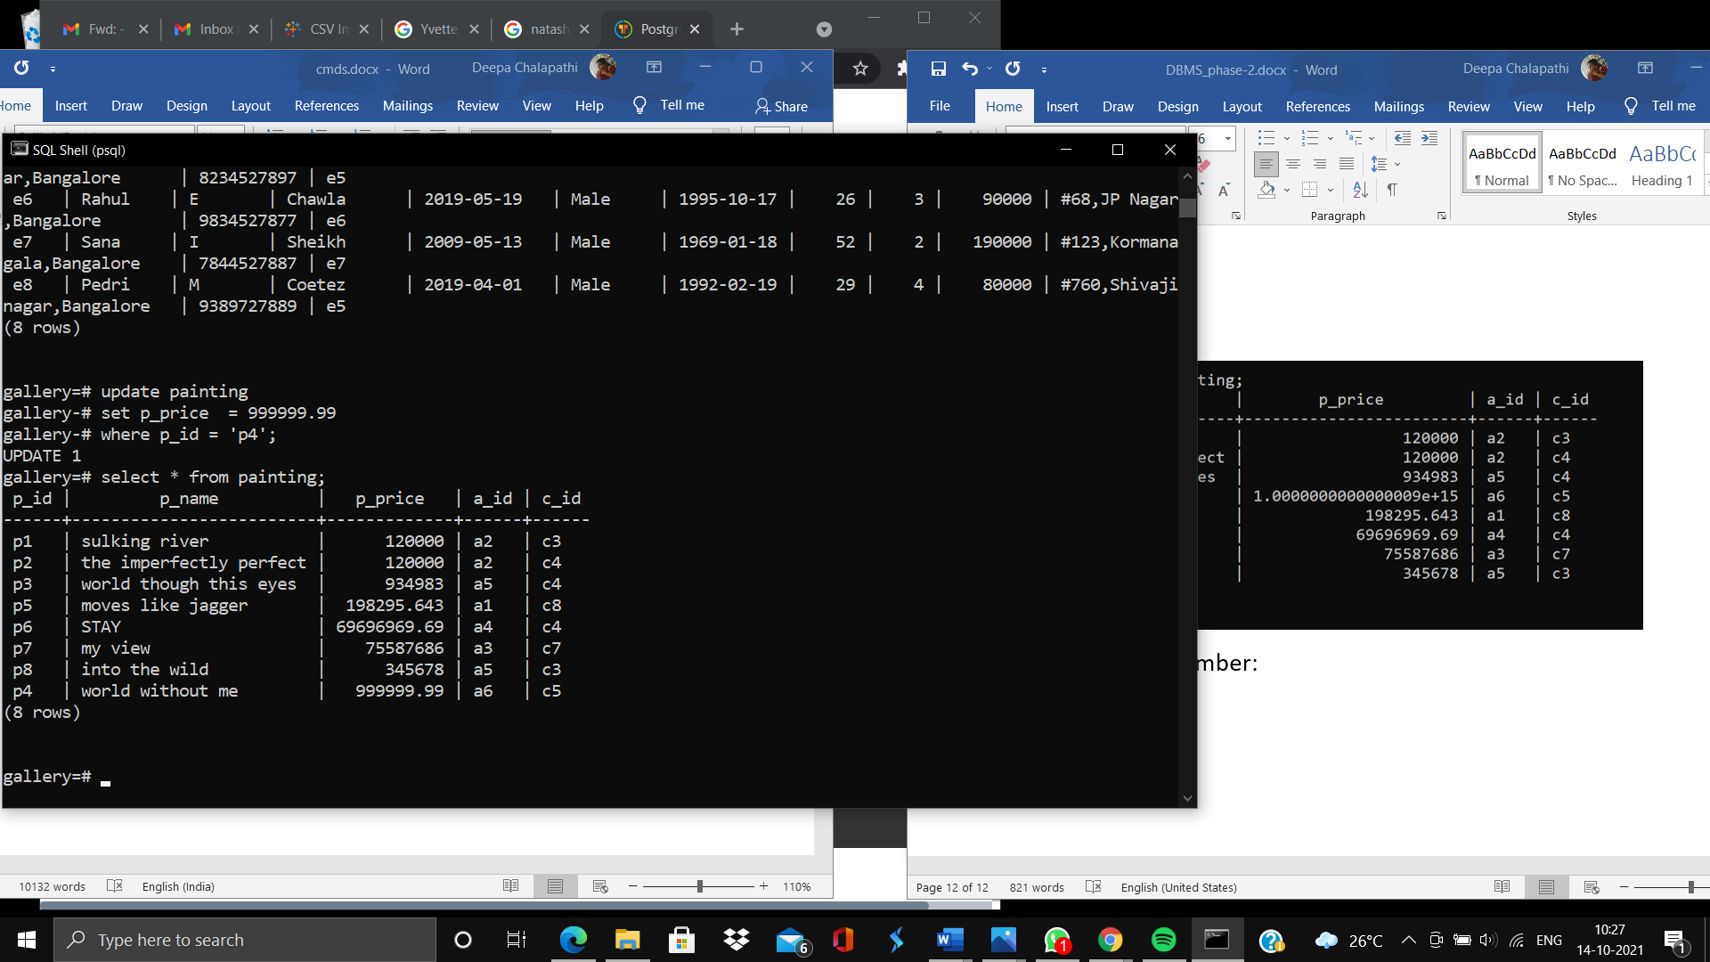

**Contribution of each member:**

Deekshitha- Relational diagram, Insert statements for customer relation, Report of the relational diagram

Deepa-Create and Insert commands, report for the insert and create statements